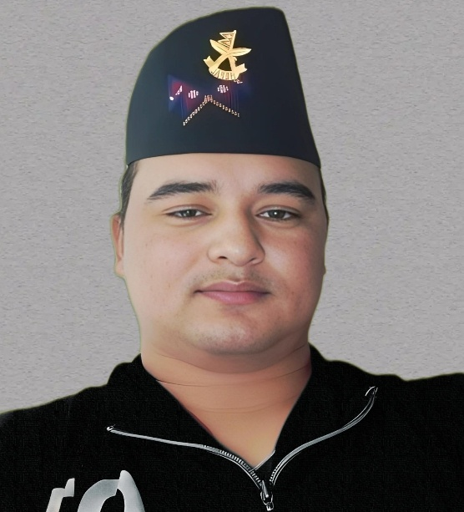
Contact:
- [Full Name] :- Dev Bahadur Darji
- [Address] :- Beni 05 Pulapurundy Myagdi Nepal
- [Phone Number] :- +974053690_55016252
- [Email Address] :- dev46-cpr@gmail.com cprdevnarayan4@gmail.com

DEV BAHADUR DARJI
CV

Summary:
I am a Certified Electrician technician, I have read about this field and I have been working in this field Highly skilled electrician with over 12 /13 years of experience in installation, maintenance, and repair of electrical systems. Proficient in reading blueprints and schematics, troubleshooting electrical problems and providing effective solutions. Dedicated to ensuring compliance with all safety regulations and codes.
Education :- Schools / University
- Shree Janaklyan Higher Secondary Schools
- Myagdi Muntipal Campus Beni Myagdi
- Heron Technical insdustries Pvt Ltd Kashi , Nepal
- Council for Technical Education & Vocational Training LTD. Gandaki , Pokhara
- Pachhimanchal Education & Technical insdustries Ltd Kaski , Nepal
- Nepal Electricity Center LTD. Kaski Pokhara,Nepal
Personal Details:
- Date of Birth : 24/05/1989
- Marital Status : Marriage
- Nationality : Nepal
- Passport No. 11114330
- Religion : Hindu
- Gender : Mal
Experience:

- Electrician:- Works
- (SACC) Sungdo Arabia Contracting Ltd. Company Saudi Arabia (2009 to
- (MAC) Modern Arab Construction Co.Ltd Company Saudi Arabia 2011)
- (CRC) Construction & Reconstruction Engineering Company Dorra,Group Doha,Qatar (2012) to (2016)
- (JTC) Al Jaber Trading & Contracting Co.W.L.LCompany Doha, Qatar (2019) to (2023)

Skills:
- Installed, maintained, and repaired electrical systems in commercial and residential properties.
- Performed electrical installations including wiring, conduit, and lighting fixtures.
- Diagnosed and rectified electrical faults and ensured safety of all systems.
- Conducted regular maintenance checks and created maintenance schedules.
- Managed large electrical projects and coordinated with other contractors.
- Maintained and repaired HVAC, plumbing and security systems.

Projects :
- Electrician
- Sungdo Arabia Contracting LTD. Saudi Arabia
Watar Gas Plant Project (Package 3) project of Saudi Aramco
- Watar & Gass Paland Mainifa , Project Saudi
2009/2011 (MAC)
- MKH) Project Lusaill 2012/2014 (CRC)
- Vindammol Project Marina Sity Lusaill 2014/2016 (CRC)
- ACS) Project Lusail (315) 2018/2020 (JTC)
- QSDP
- (PPP) Schools Development Pragram Package -1 (JTC) Site 322
Still.At Company (2023)

Languages : Nepali , Hindi , English , Arbic

Objective:

- I am a certified electrician technician, I have read about this field and I have been working in this field for 12/14 years now. Home work big building, big plan, factory to big project, house wiring electrical repair electrical problem solving , Electrical Maintenance repairing window AC air AC internet connection installation panel breaker, switch, socket, DB board, smoke alarm, light, fan etc. I can do a lot of work from distribution! Having worked in many sites and many projects in this field, my schooling has made me a well-experienced person, and I will gain more experience and be able to solve every electrical problem! ! And I have been able to work in this field both in my country and abroad! Having worked on large projects of large companies in countries like Saudi and Qatar, I have experience working on the construction site! As far as I think I have the ability to work related to electricity!!

Summary:
Highly skilled electrician with over 12 years of experience in installation, maintenance, and repair of electrical systems. Proficient in reading blueprints and schematics, troubleshooting electrical problems and providing effective solutions. Dedicated to ensuring compliance with all safety regulations and codes.

Additional Information:-
Certified Electrician with 12/14 years of residential and commercial experience focusing on diagnostics, repairs, and installations. I am and continue to be passionate about mentoring, coaching, and mentoring others. Also experienced in hot tubs, electrical panel upgrades, garage and shed wiring, smoke alarms, surge protectors, ceiling fans and light installations, and whole house construction and plant re-house wiring, panel wiring, internet, AC wiring. I can do any work related to electricity. I have a lot of experience in this field. I have experience and full confidence about my work. I can do this work easily. I will work well from my side in any electrical field and I will try to give the best. I have read and learned a lot about taking care of your own safety and the safety of others!!
Achievements & Awards
- Works Experienced Certificate Electrician
- Schools Certificate
- Training Experienced Certificate
- Diploma Certificate
- Company Experienced Certificate & Awared

